SHADOW FOX

BEGINNER LEVEL – TASK

Name: DHARUN T
Domain: Data Science
ShadowFox Program ID (SF-PID): SF-PID-2026-G 1241

Task Level – Beginner
Visualization Library

Visualization
Data visualization uses charts, graphs to present the data’s clearly and in simple way. This turns down the complex data into visuals that are easy to understand.
Data visualization is the most important in Data Science because it helps the user to understand the trends, relationships and patterns from huge raw data.
In python, data visualization has multiple libraries like Matplotlib, Seaborn, Plotly, Pandas, Bokeh, Altair and Folium.
Among these data visualization python libraries Matplotlib and Seaborn were chosen.
(1)
1.Matplotlib
Matplotlib is developed by John D. Hunter. Matplotlib is a low level graph plotting library in python.
Matplotlib is an open source so anyone can access it in free of cost.
Matplotlib is made to work with NumPy arrays and Pandas Data frames.
Matplotlib is used to plot 2D graphs.
A Matplotlib contains:
- Figure: Figure is a top level container for an example a empty sheet where graph is drawn is known as Figure
- Axes: Axes is a plotting area inside the figure where data is displayed. Axes has parts that are X-axis, Y-axis, Label and Grid.
- Axis: Axis is the number line X-axis and Y-axis.
- Lines and Markers: Lines connect the data points and Markers denotes individual data points in different colours.
- Title and Labels: Title represents the name of the plot and label represent the data in each axis.

2.Pyplot
Pyplot is a collection of module in Matplotlib library that provides an simple interface for creating plot
We import Pyplot from Matplotlib as follow

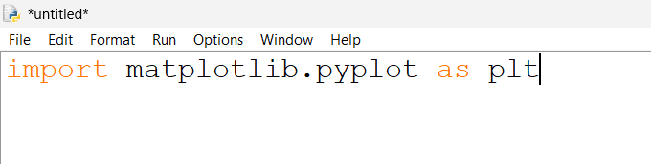

3.Types of Matplotlib
Matplotlib has various types of graphs
- Line Graph
- Bar Chart
- Histogram
- Scatter plot
- Pie Chart
3.1 Line Graph
Line Graph is one of the types in Matplotlib. Line Graph is used to show relationship between two continuous variables by connecting data point through straight line is known as Line Graph.
It is used to visualize the trends, patterns etc.
Simple example for Matplotlib:
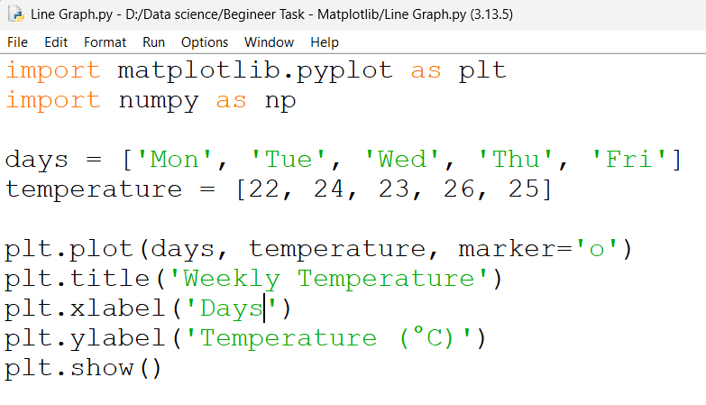

Output:
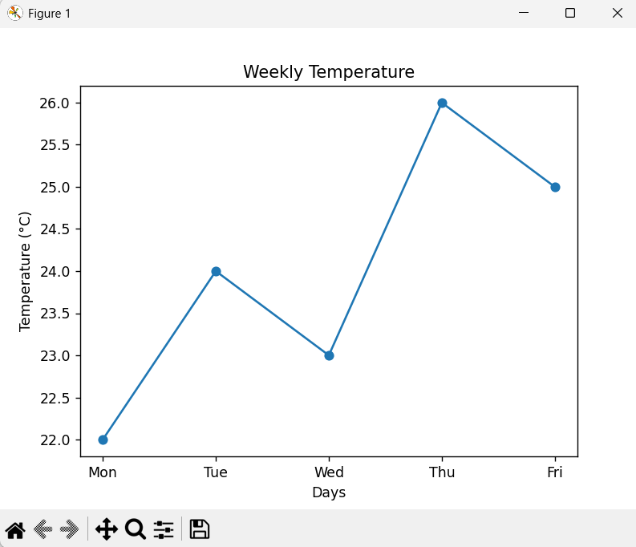

3.2 Bar Chart
Bar Chart is a graphical representation that represents the data categories using rectangular bar and the height and length od the rectangular bar depends on their value.
Bar chart is also used to visualize trends, surveys etc. in clear view.
In bar chart user can customize it’s colour and it allows multiple bars in same data categories.
Simple example for bar chart
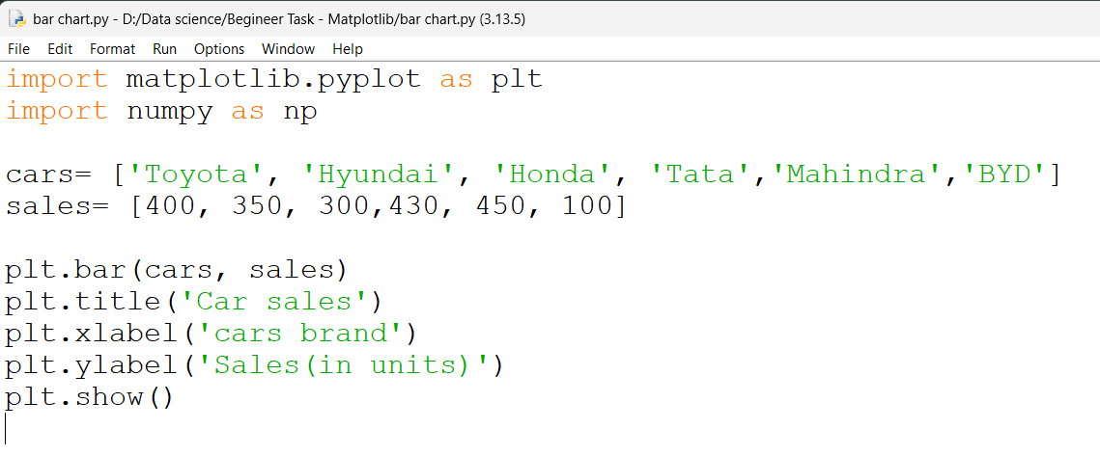
Output
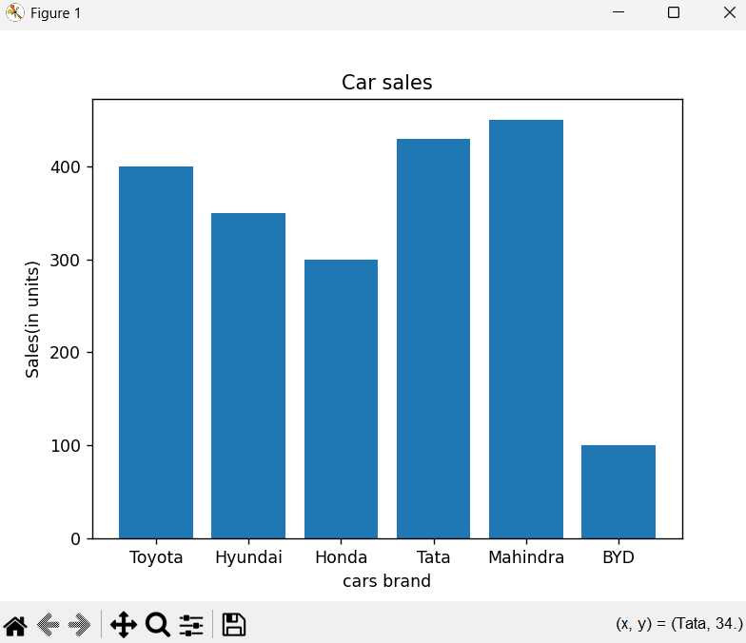

3.3 Histogram
Histogram is also a graphical representation and it represent the data distribution by grouping the data into ranges is known as histogram (or) histogram shows the frequency of data within intervals.
Histogram is one of the most important tool in visualization to visualize the data.
Simple example for histogram
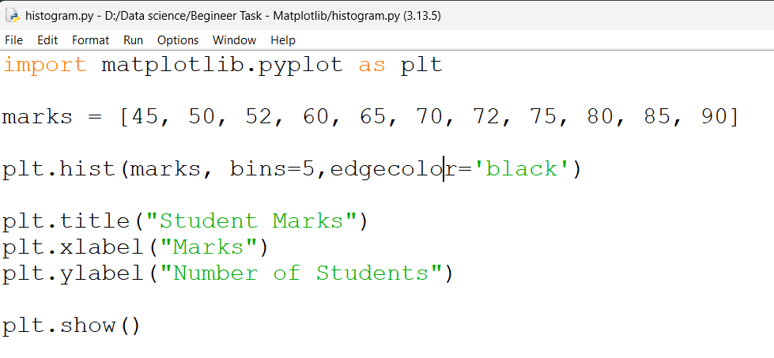
Output
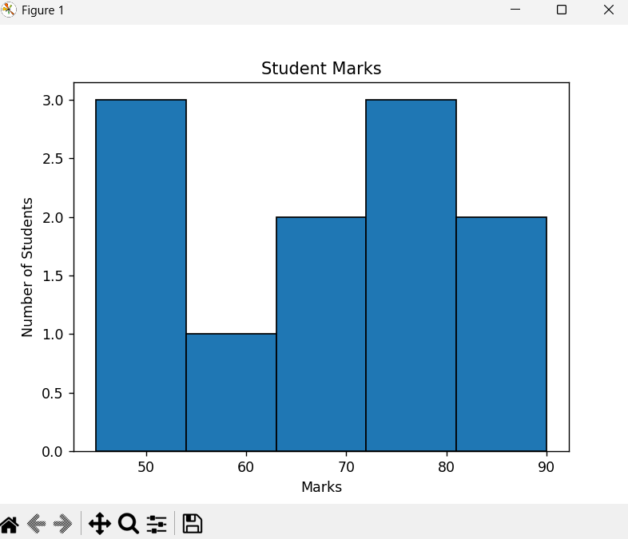

Students marks are grouped for some certain interval and split into 5 bins.

3.4 Scatter Plot
Scatter plot is used to show the relationship between the two numerical variables using dots.
Scatter plot is 2D visualization tool.
Types of Scatter plot
- Positive Correlation
- Negative Correlation
- No Correlation

3.4.1 Positive Correlation
In Positive Correlation scatterplot if Y-axis value increases then X-axis value is also increases. Positive correlation is classified into perfect positive correlation ,high positive correlation and low positive correlation.
3.4.2 Negative Correlation
In Negative correlation scatterplot if Y-axis value is decreases then X-axis value will increases. Negative correlation is classified into perfect negative correlation ,high negative correlation and low negative correlation.
3.4.3 No Correlation
In this type of correlation all the points or dots appears in random way. There is no correlation between two variables.
Simple example for scatter plot
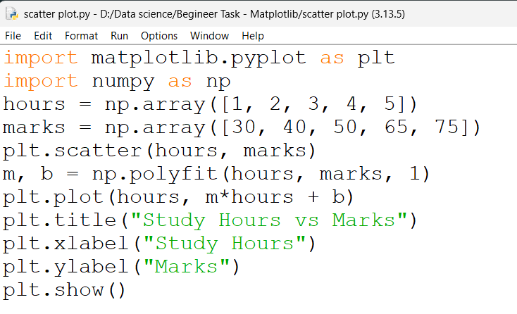

Output
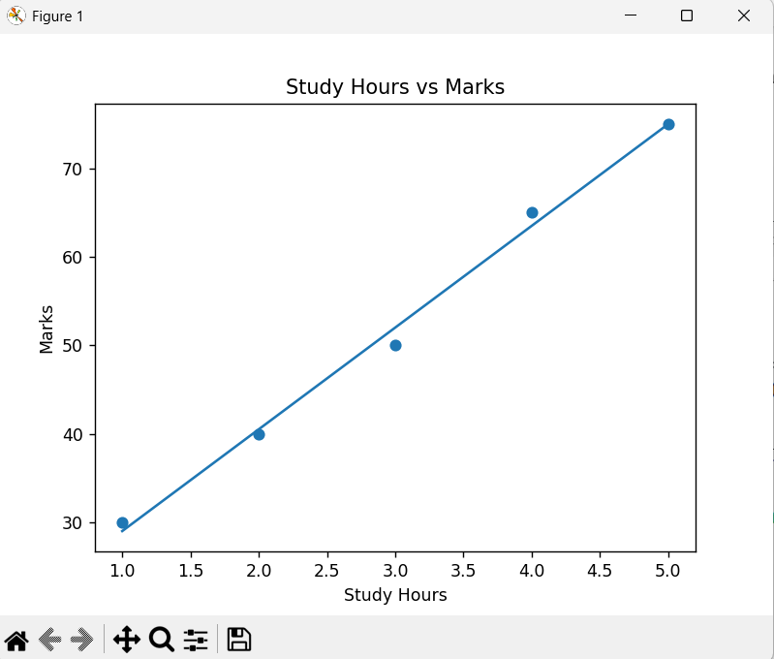
3.5 Pie chart
Pie chart is circular graph that divides the data into slices and allows the comparison between different data categories. This pie chart makes the complex data into simpler way for visualization.
Pie chart is one of the most important tool for data visualization it breaks the complex data into simpler way.
Pie chart formula:
(Given Data / Total Value of Data) × 360°
Example:
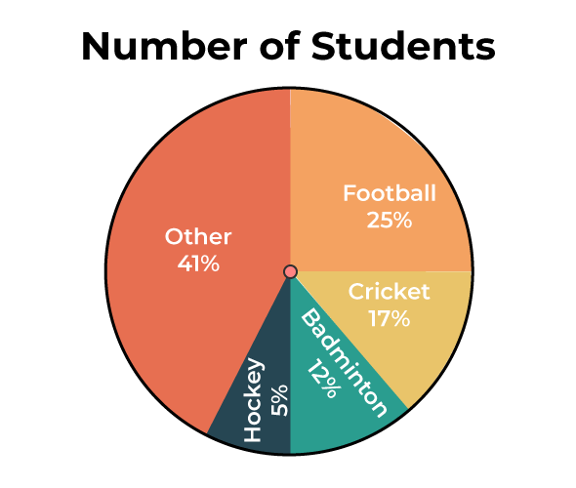

Simple example for pie chart
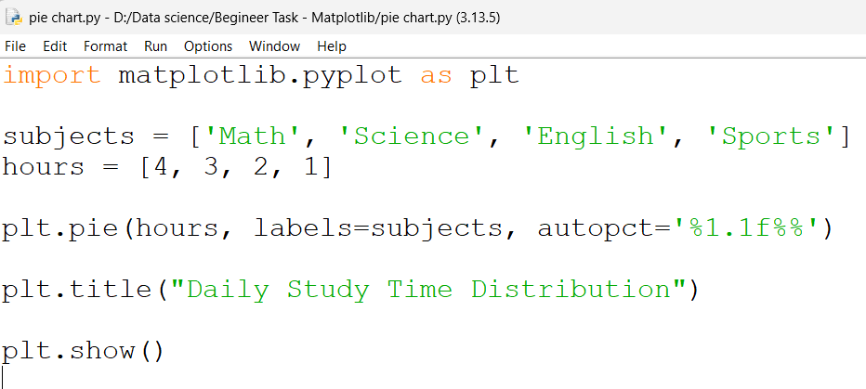
Output
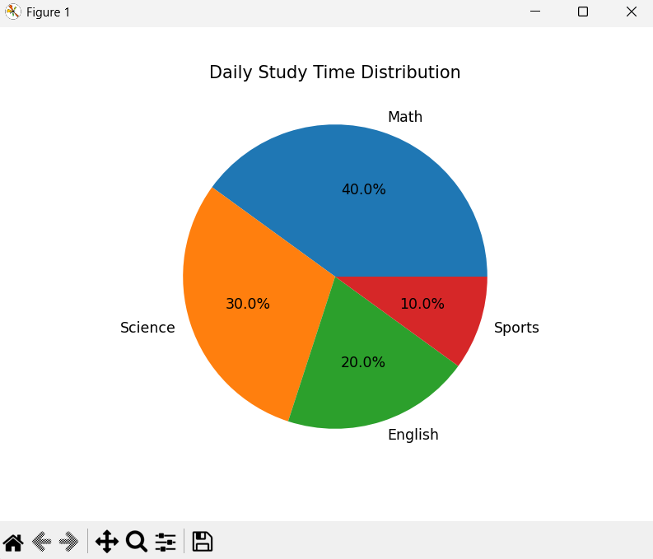

(2)
2. Seaborn
Seaborn is one of the python library used to visualize the data. Seaborn has attractive colour pallets and easier to study the data. Seaborn is built on matplotlib and integrated with pandas. Seaborn works directly on pandas data frame.
Seaborn is used for Exploratory Data Analysis(EDA). Seaborn is used for visualize the data before implementing it in machine learning model.

2.1 Types of Seaborn
- Distribution Plots
- Relational Plots
- Categorical Plots
- Matrix Plots

2.1.1 Distribution Plots
Distribution plot is used to show how a data is distributed among the range is known as Distribution plot and these separated data is shown in graph.
Distribution plots have two types
- Histogram
Histogram uses bars to represent the frequency of data.
A simple example:

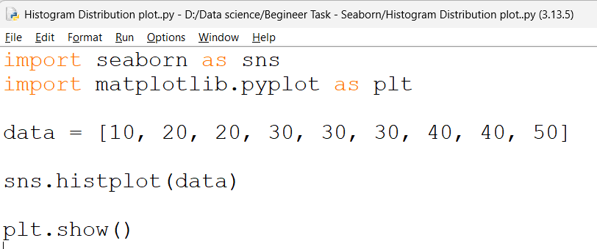

Output:

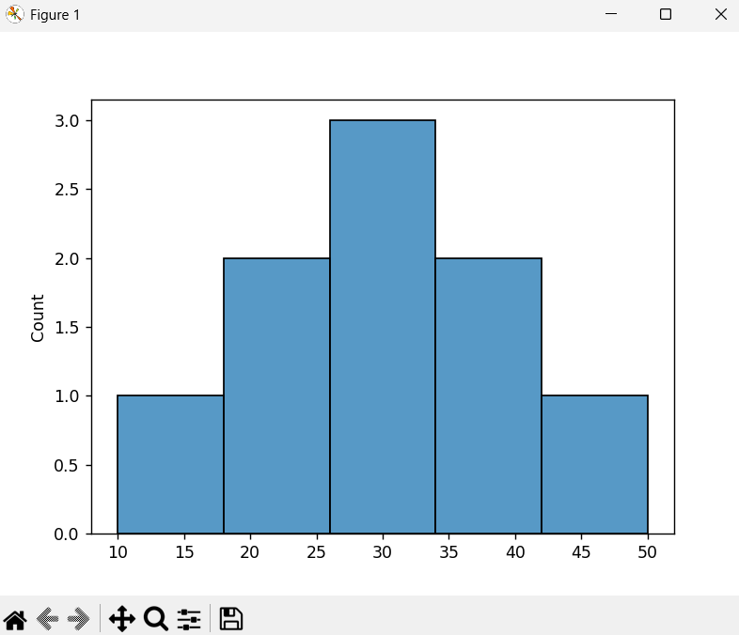

- KDE plot (Kernal density estimation)
In KDE plot the data are in visualized using curves (smooth curves). By using the KDE plot we can visualize the shape of data like increasing and decreasing.
A simple example for KDE plot

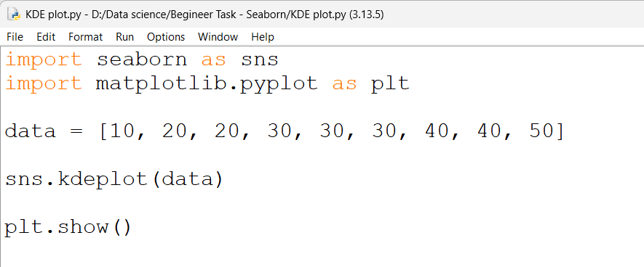

Output

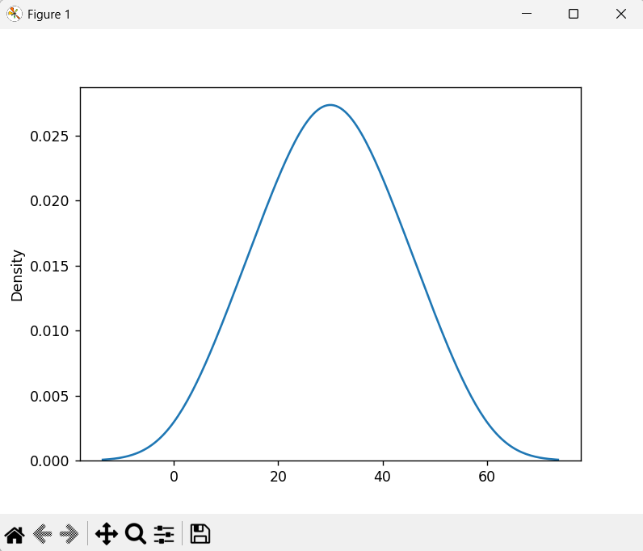

2.2.2 Relational Plot
Relational plot is used to visualize the relationship between two or more variables. Relation plots help in visualizing the trends, patterns and correlation among data.
Types in Relation plots
- Scatter plot
Scatter plot represents the data as points in 2D graph where each points corresponds to the value
A simple example for Scatter plot
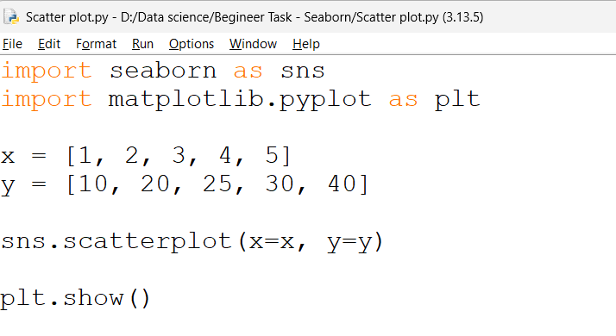

Output

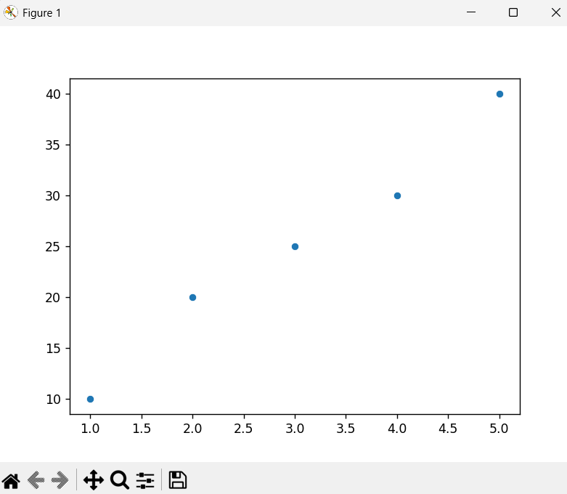

- Line plot
Line plot is used to show the relationship between the variables for a continuous interval of time.
Line plot is helpful to visualize the growth and decline pattern easily.
A simple example for Line plot
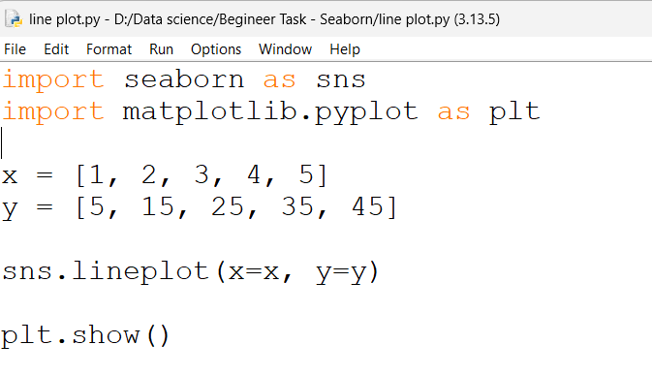

Output

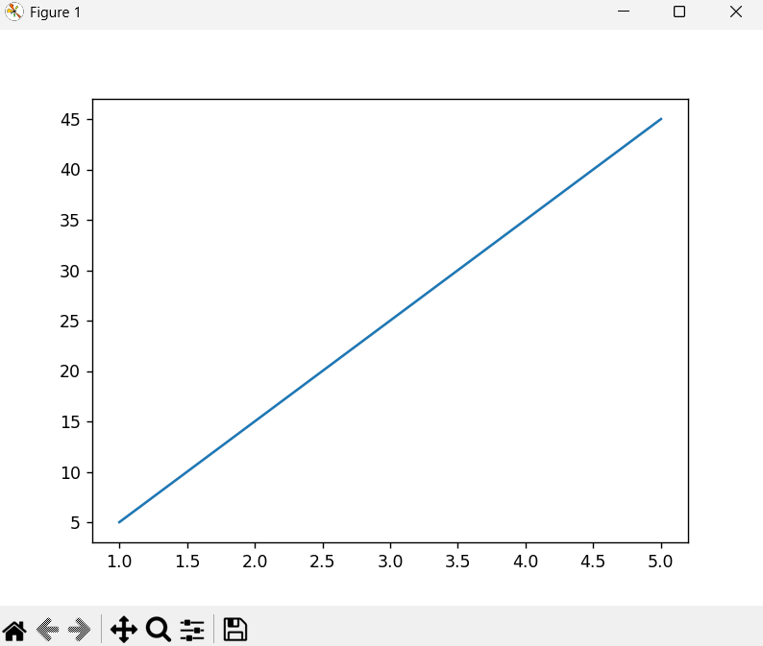

2.2.3 Categorical Plots
Categorical plots are used to visualize and compare the data among different categories. Categorical plots is helpful to understand the changes in numerical variable in categorical variables.
There two types of categorical plots
- Bar plot
Bar plot is use rectangular bars to represent the data. This rectangular bar is represented by height and the height of the bar is equivalent to the value it represents.
Bar plot allows easier comparison between two different categories or groups.
A simple example for Bar plot
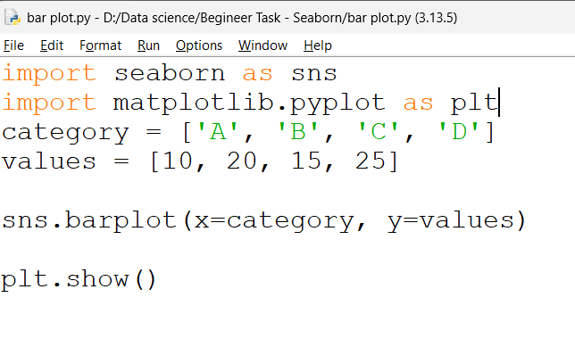

Output
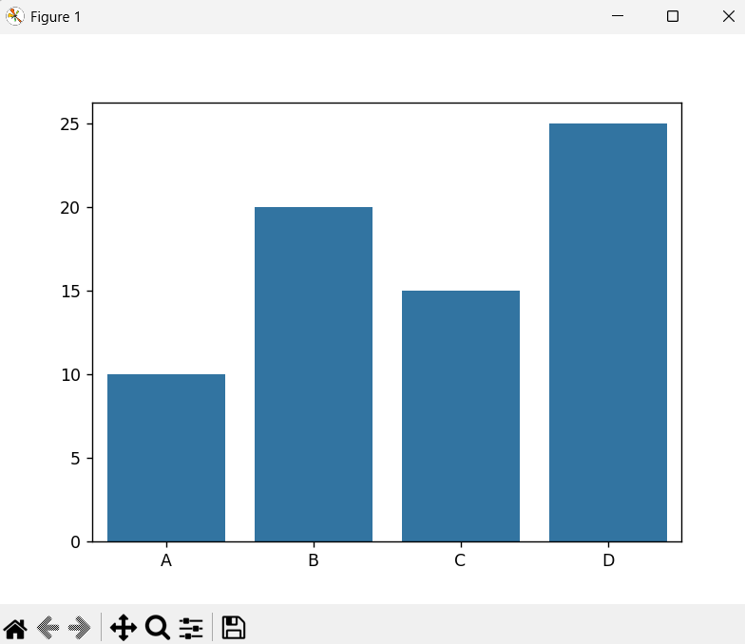

- Count plot
Count plot is used to represent the number of occurrences of each categories in each data set is known as count plot
Count plot is represented by using the rectangular bar chart by height which is equivalent to the data or value.
A simple example for Count plot
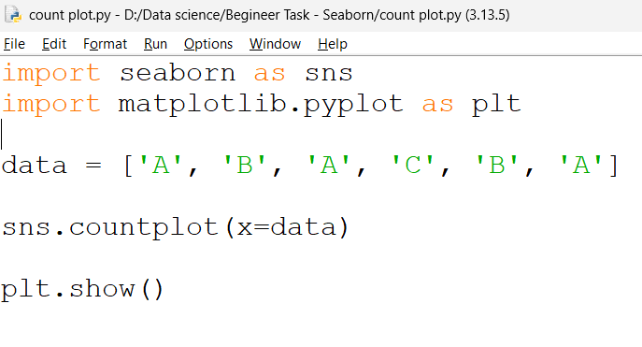

Output

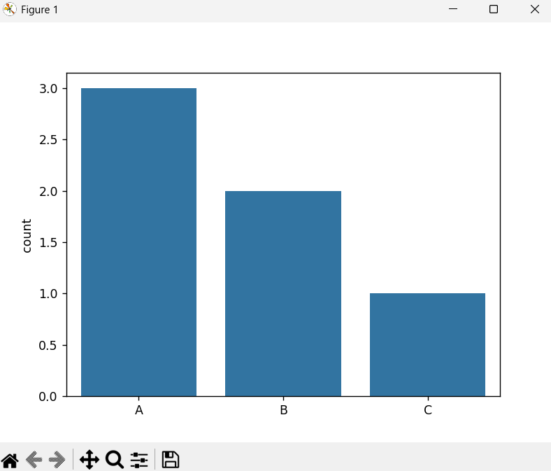

2.2.4 Matrix Plots
Matrix plot is used to visualize the data in matrix form. Matrix plot is used to create a correlation matrix between multiple variables is known as Matrix plot.
Matrix plot is used to crack the large amount of data into smaller once with more attractive colours.
There are two types in it
- Heatmap
Heatmap is a graphical representation to show the data in an individual value matrix form in different colours is known as Heatmap.
It is used to display correlation matrix.
Heatmap is used to represent the temperature, AQI, pollution level and etc.
A simple example for heatmap

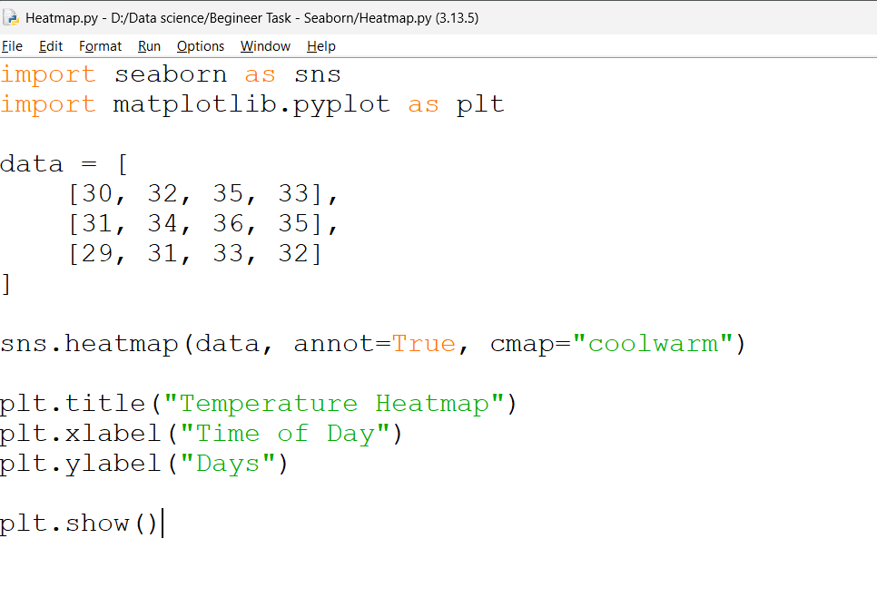
Output
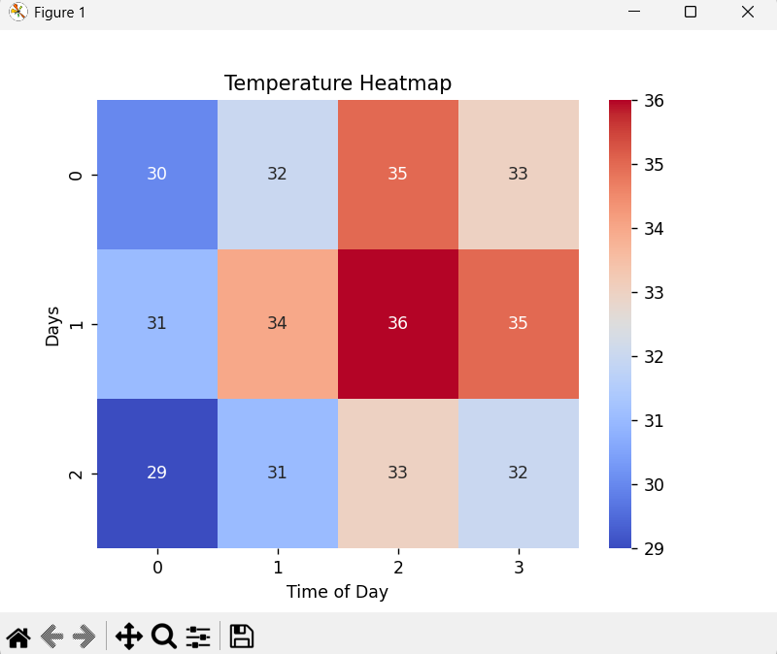

- Clustermap
Clustermap is an advanced version of heatmap in clustermap it groups the similar data points using hierarchical clustering.
In clustermap it uses tree diagram to show the clustering.
A simple example clustermap

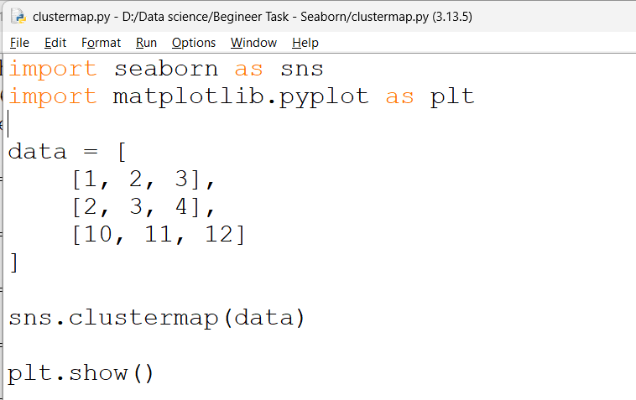

Output

